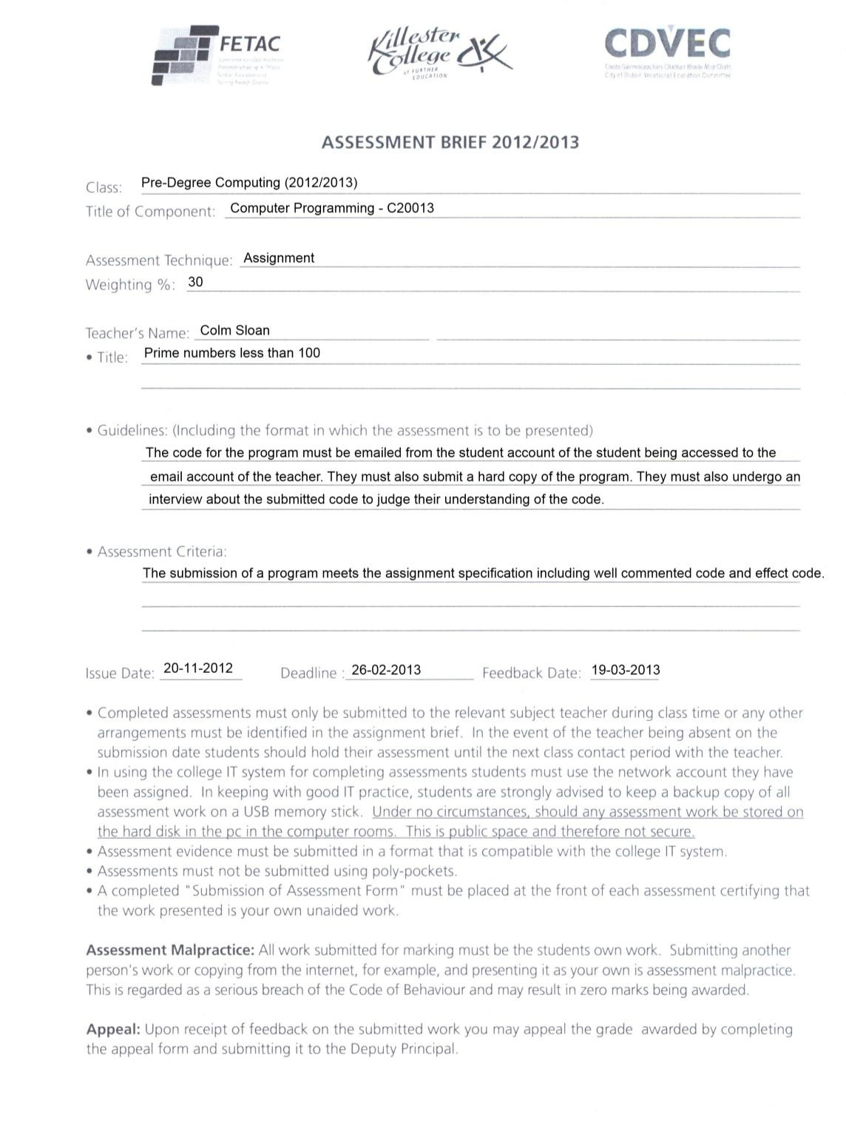

Programming in C Assignment

**Deadline**: 26-02-2013 before 10:00pm

# Marking Schedule: 90 total marks

* Clearly documented program code – 15 marks o what the code does AND how it does it o in this case, let the comments be the documentation
* Excellent screen layout – 15 marks o console output should be information, neat and readable
* Effective code layout – 15 marks o following the style guide ([http://googlestyleguide.googlecode.com/svn/trunk/cppguide.xml)](http://google-styleguide.googlecode.com/svn/trunk/cppguide.xml)

o e.g. proper indentation, spacing, brace placement etc.

* Accurate programming (syntactically and semantically) – 30 marks o marks for each step in the process that works o try to repeat code as little as possible o prefer simple solutions o minimizes processing and memory requirements
* Appropriate testing – 15 marks o Validate user input i.e. warn user for every possible mistaken input they can give e.g.

too high an index, too low an index etc.

# Assignment:

A prime number is a positive integer greater than 1 that can be evenly divided (no remainder) by itself and 1. See Wikipedia and other resources if this definition is still unclear. A program should be created that calculates all prime numbers less than 100, display all of those prime numbers, display the number of prime numbers found and allow a user to print out the *n*th prime by typing the integer *n* e.g. if the user enters 3, the 3rd prime number, 5, should be displayed. The user should be shown informative instructions. Inform the user of any invalid user input to make sure it is a valid index and inform the user of why there was an error e.g. the user enters an index value less than 1. Allow the user to re-enter their input if their input is invalid. Allow the user to exit the program by entering -1 as input. Inform the user that -1 exits the program.

Prime numbers must be calculated within the program. They cannot simply be hard-coded by the programmer i.e. the programmer cannot simply hand-write a list of the prime numbers such as {2, 3, 5, 7, 11, …}. These prime numbers must be found using at least one for loop and one if statement. The prime numbers must be stored in an array.

All console message output should be neat and easily understood. No functions or procedures should be called other than the main function, printf and scanf. This includes built in C functions such as sqrt.

# Submission:

E-mail program code and hand in a printed copy of the code by the deadline. Each student will undergo an interview about their code to make sure they understand it. Results will be received within three weeks of submission (before 19-03-2013).